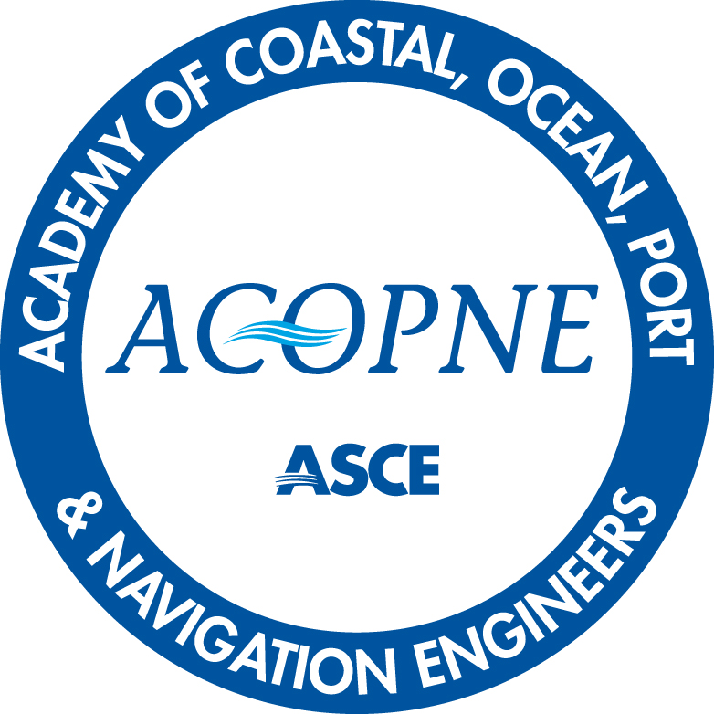

APPLICATION FOR
BOARD CERTIFICATION IN
Coastal (BC.CE), Ocean (BC.OE), Port (BC.PE)
OR Navigation EngineeRING (BC.NE)

Eligibility Requirements:

- Active practice.
- P.E. license.
- Bachelor’s degree in engineering.
- Master's degree in civil Engineering or related degree.
- 10 years professional experience in coastal, ocean, port, or navigation engineering, of which 8 years was gained after the first P.E. license.
- Attainment of the requisite Body of Knowledge.
- Adherence to the ASCE Code of Ethics.

For detailed eligibility information, visit asce.org/certification and navigate to Coastal, Ocean, Ports or Navigation Engineering page.

Questions? Contact us cec@asce.org

Coastal, Ocean, Port & Navigation
Board Certification Application

(Please complete this application form and send with your Resume/C.V. and payment of $350 for ASCE or Institute members and $450 for non-members
for each certification for the initial year.)

BOARD CERTIFICATION (please indicate which Board Certification(s) you are applying for:

___ Board-Certified Coastal Engineer (BC.CE)

___ Board-Certified Ocean Engineer (BC.OE)

___ Board-Certified Port Engineer (BC.PE)

___ Board-Certified Navigation Engineer (BC.NE)

Where did you hear about the certification program?
- Website
- Email from ACOPNE, CEC, or ASCE
- Friend or colleague
- Advertisement (Smart Brief, newsletter, or magazine ad)
- Visited exhibit booth at a conference
- Attended a ceremony
- Other:_________________________

Application Checklist

- Completed Application (including payment)
- Resume or C.V.
- Three Professional Reference Forms (no more than two from any one organization)

Personal Information:
Name:
Designations:
Position:
Organization:
Address:
Phone:
E-Mail Address:

Education: (Please list name of school, city, state/province, country, and month/year of degree)
Bachelors:

Masters:

Doctoral:

Experience (backdating at least 12 Years – List Title, Organization, Dates):
The details supplied to support the applicant’s experience should include, the project owner, project details, project location, cost value, role of the applicant, how it relates to the specialty area applied for, and how long the applicant worked on the project.
1.
2.
3.
Honors/Awards:
1.
2.
3.
Publications:
1.
2.
3.
4.

Month/year and jurisdiction I first achieved P.E. licensure:

Current P.E. Licensure Information OR Foreign Equivalent Registration or Licensure:
State(s)/ If non-U.S., Country(s):
License numbers (date of expiration):

Have any of your current or past P.E. licenses ever been in violation, suspended, revoked, surrendered, cited or had any other actions, voluntary or enforced, similar to those previously listed, against your P.E. license?
___Yes
___No
(If yes, please describe and attach additional pages as necessary)

Mastery of Body of Knowledge Criteria

You must have developed mastery in at least ONE of the following four elements of the Body of Knowledge related to coastal, ocean, port or navigation engineering. Please address the element(s) to the best of your knowledge. If more space is needed, you may submit separately as attachments with this application.

1 - Specialized area related to civil engineering. Professional Engineer, through a combination of education, experience, and corresponding accomplishments, has demonstrated a high level of skill in a specialized area of Coastal, Ocean, Port, or Navigation engineering. ACOPNE encourages certification in area(s) of coastal, ocean, port, or navigation engineering specialization.

2 - Project management, construction, and asset management. Professional Engineer, through education, experience, and corresponding accomplishments, has demonstrated a high level of skill in the management of complex coastal, ocean, port, or navigation engineering projects.

3 - Business, public policy and public administration. Professional Engineer, through education, experience, and corresponding accomplishments, has demonstrated a high level of skill in the evaluation of business plans, public policy recommendations, and a system of public administration in support of coastal, ocean, port, or navigation projects.

4 - Leadership principles and attitudes. Professional Engineer, through education, experience, and accomplishments, has demonstrated a high level of skill in providing leadership with respect to complex coastal ocean port & navigation engineering projects. ACOPNE encourages participation and leadership in professional societies, board of registrations, and national review panels, etc.

PROFESSIONAL ETHICS
ASCE Code of Ethics

PREAMBLE
Board-Certified Engineers of The Academy of Coastal, Ocean, Port & Navigation Engineers shall conduct themselves with integrity and professionalism, and above all else protect and advance the health, safety, and welfare of the public through the practice of civil engineering.

Engineers govern their professional careers on the following fundamental principles:
• create safe, resilient, and sustainable infrastructure;
• treat all persons with respect, dignity, and fairness in a manner that fosters equitable participation without regard to personal identity;
• consider the current and anticipated needs of society; and
• utilize their knowledge and skills to enhance the quality of life for humanity.

Board-Certified Engineers of the Academy of Coastal, Ocean, Port & Navigation Engineers shall commit to the following ethical responsibilities. In the case of a conflict between ethical responsibilities, the five stakeholders are listed in the order of priority. There is no priority of responsibilities within a given stakeholder group with the exception that 1a. takes precedence over all other responsibilities. ¹

CODE OF ETHICS
- SOCIETY
Board-Certified Engineers:
a. first and foremost, shall protect the health, safety, and welfare of the public;
b. enhance the quality of life for humanity;
c. express professional opinions truthfully and only when founded on adequate knowledge and honest conviction;
d. have zero tolerance for bribery, fraud, and corruption in all forms, and report violations to the proper authorities;
e. endeavor to be of service in civic affairs;
f. treat all persons with respect, dignity, and fairness, and reject all forms of discrimination and harassment;
g. acknowledge the diverse historical, social, and cultural needs of the community, and incorporate these considerations in their work;
h. consider the capabilities, limitations, and implications of current and emerging technologies when part of their work; and

i. report misconduct to the appropriate authorities where necessary to protect the health, safety, and welfare of the public.

- NATURAL AND BUILT ENVIRONMENT
Board-Certified Engineers:
a. adhere to the principles of sustainable development;
b. consider and balance societal, environmental, and economic impacts, along with opportunities for improvement, in their work;
c. mitigate adverse societal, environmental, and economic effects; and
d. use resources wisely while minimizing resource depletion.

- PROFESSION
Board-Certified Engineers:
a. shall uphold the honor, integrity, and dignity of the profession;
b. practice engineering in compliance with all legal requirements in the jurisdiction of practice;
c. represent their professional qualifications and experience truthfully;
d. reject practices of unfair competition;
e. promote mentorship and knowledge-sharing equitably with current and future engineers;
f. educate the public on the role of civil engineering in society; and
g. continue professional development to enhance their technical and non-technical competencies.

- CLIENTS AND EMPLOYERS
Board-Certified Engineers:
a. shall act as faithful agents of their clients and employers with integrity and professionalism;
b. make clear to clients and employers any real, potential, or perceived conflicts of interest;
c. communicate in a timely manner to clients and employers any risks and limitations related to their work;
d. present clearly and promptly the consequences to clients and employers if their engineering judgment is overruled where health, safety, and welfare of the public may be endangered;
e. keep clients’ and employers’ proprietary information confidential;
f. perform services only in areas of their competence; and
g. approve, sign, or seal only work products that have been prepared or reviewed by them or under their responsible charge.

- PEERS
Board-Certified Engineers:
a. shall only take credit for professional work they have personally completed;
b. provide attribution for the work of others;
c. foster health and safety in the workplace;
d. promote and exhibit inclusive, equitable, and ethical behavior in all engagements with colleagues;
e. act with honesty and fairness on collaborative work efforts;
f. encourage and enable the education and development of other engineers and prospective members of the profession;
g. supervise equitably and respectfully;
h. comment only in a professional manner on the work, professional reputation, and personal character of other engineers; and
i. report violations of the Code of Ethics to the Academy of Coastal, Ocean, Port & Navigation Engineers.

------------------
¹This Code does not establish a standard of care, nor should it be interpreted as such.

I attest that I have read, understand, and accept the ASCE Code of Ethics and agree to adhere to it. I further understand and agree that violation of the ASCE Code of Ethics is grounds for expulsion from the ACOPNE and my Board-Certified credential.

Signature Date

ORAL EXAMINATION CONSIDERATIONS

ACOPNE requires all qualified applicants to take the Board-Certified oral examination unless specifically waived and will work to address all reasonable disability related accommodations disclosed with this application. Please note, ACOPNE conducts oral assessments virtually through Microsoft Teams online meeting platform.

Please check one of the two options:

1. I DO NOT have a disability (as defined by the Americans with Disabilities Act or other applicable state or local law/regulation) that requires reasonable accommodation during the oral assessment.

2. I HAVE a disability (as defined by the Americans with Disabilities Act or other applicable state or local law/regulation) that requires reasonable accommodation during the oral assessment.

If you checked item 2 and indicated that you have (YES) a disability that requires reasonable accommodation during the oral assessment, please provide:

(1) documentation on your disability (please attach letter or other disability documentation from qualified expert such as treating physician)

(2) a brief explanation of how this disability impacts your ability to take the oral assessment,

and

(3) your requested reasonable accommodation.

The Academy retains the right to verify the claimed disability and provide reasonable accommodation of its choosing to enable equal access to the oral assessment.
By signing this page, the applicant agrees and attests that no reasonable accommodations are required beyond those outlined above.

Signature Date

PAYMENT INFORMATION
($350 for ASCE or Institute members/ $450 for non-members)

Please note, the application fee is part of a multi-step application process and is non-refundable. Please confirm you meet the eligibility requirements before paying your application fee.

Application steps for board certification:
1. Submit the completed application and your resume or C.V.
2. Pay the application fee(s) online for either: Coastal engineering, Ocean engineering, Port engineering, or Navigation engineering.
3. Send the reference form to a minimum of three references (must be licensed professional engineers).*
*If only 3 references are submitted, each reference must be from separate organizations.

Once all application documents are received, the application will be reviewed by the Admissions Committee. A status of application will be provided to you after full review by the Admissions Committee.

Ready to Submit your Application Fee?
Select payment method below:

__ Pay the application fee(s) online for either: Coastal engineering, Ocean engineering, Port engineering, or Navigation engineering. (*RECOMMENDED Method)

__ *I will mail a check made payable to the “Civil Engineering Certification (CEC)”.

*Please send checks to:
ASCE
Attn: Accounting Dept.
1801 Alexander Bell Dr
Reston, VA 20191
USA

IMPORTANT: Please submit your completed application form, resume, minimum of 3 professional references by email to cec@asce.org to move forward with your submission.

